Marketing research for books
1);

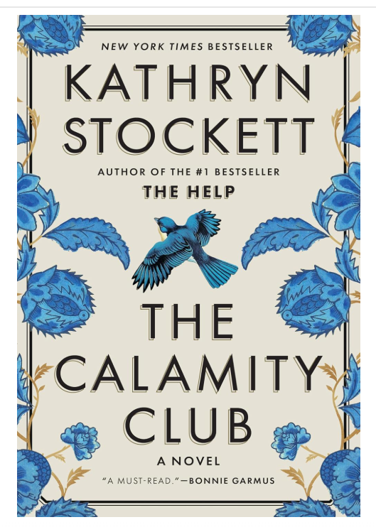

Title:-The Calamity Club

Auther:-Kathryn Stockett

Publication Details

Publication date:-May 5, 2026

Publisher:-Spiegel & Grau

Language:-English

Pages:-656

Genre:-Historical fiction

Introduction

The Calamity Club: A Novel is a historical fiction novel written by Kathryn Stockett. The book was published on May 5, 2026, by Spiegel & Grau. Set in Oxford, Mississippi, during the Great Depression of 1933, the novel explores themes of friendship, resilience, hope, and women's empowerment. Through its engaging storyline and memorable characters, the novel presents the challenges faced by people during difficult economic times.

Author Background

Kathryn Stockett is an American novelist best known for her bestselling novel The Help. Her works often focus on social issues, human relationships, and the experiences of women. The Calamity Club continues her tradition of creating strong characters and emotionally powerful stories.

Summary of the Book

The story follows eleven-year-old Meg Lefleur, an orphan living in difficult circumstances. Despite many hardships, she remains determined and hopeful. Another important character is Birdie Calhoun, an outspoken woman who returns to Oxford to help her struggling family. As the story develops, the characters face personal and social challenges while learning the importance of friendship, courage, and perseverance.

The novel provides a vivid picture of life during the Great Depression and highlights the struggles faced by women and families during that period.

Main Themes

1. Friendship

The novel emphasizes the importance of friendship and support during difficult times.

2. Women's Empowerment

Strong female characters demonstrate courage, independence, and determination.

3. Poverty and Economic Hardship

The story portrays the effects of the Great Depression on families and communities.

4. Hope and Resilience

The characters show strength and optimism despite facing many obstacles.

Critical Reviews

The novel has received positive reviews from critics and readers.

Oprah Daily described the book as “immersive, exciting, and fabulous.”

The New York Times praised its emotional depth and memorable characters.

Publishers Weekly highlighted its engaging storytelling and historical setting.

Strengths of the Book

Strong character development.

Rich historical background.

Emotional and engaging storytelling.

Powerful themes of friendship and resilience.

Weaknesses of the Book

The novel is relatively long, with 656 pages.

Some readers may find the historical details challenging.

Conclusion

In conclusion, The Calamity Club is a compelling historical fiction novel that explores friendship, hope, and women's strength during one of the most difficult periods in American history. Kathryn Stockett successfully creates an engaging story with memorable characters and meaningful themes. The novel is highly recommended for readers who enjoy historical fiction and character-driven stories.

References

Amazon. (2026). The Calamity Club: A Novel by Kathryn Stockett. Retrieved from Amazon Books.

⭐ 4.6 / 5 (1,091 reviews)

2).



Book Review: Bad Boy Era

Title
Bad Boy Era: A Best Friend's Twin Brother Small Town Sports Romance (Mountain Men Matchmaker Book 4)

Author
Amy Daws

Publication Details
- Author: Amy Daws
- Series: Mountain Men Matchmaker (Book 4)
- Format: Kindle Edition
- Language: English
- Genre: Contemporary Romance, Sports Romance, Small-Town Romance

Introduction
Bad Boy Era is a contemporary romance novel written by Amy Daws. The story combines romance, humor, and emotional drama while exploring themes of love, friendship, family relationships, and personal growth. Set in a charming small-town environment, the novel follows two individuals who struggle to resist their growing attraction despite complicated circumstances. With its engaging characters and romantic tension, the novel offers an entertaining reading experience for fans of modern romance.

Author Background
Amy Daws is a bestselling contemporary romance author known for writing emotional, humorous, and character-driven love stories. Her novels often feature strong chemistry between protagonists, memorable supporting characters, and themes of family, friendship, and personal growth. She has gained popularity among romance readers for her engaging storytelling style and relatable characters.

Summary of the Book
The story follows Everly Fletcher, a young woman known for her matchmaking skills but who struggles with her own love life. After returning home for the summer, she hopes for a peaceful and productive season helping at her aunt's animal rescue center.
However, her plans change when Conri “Wolf” Reilly arrives. Wolf is the twin brother of Everly's best friend and a talented Irish rugby player with a troubled reputation. After personal setbacks threaten his career, he comes to stay near Everly while trying to rebuild his life.
Although the two initially clash because of their different personalities, they gradually develop a deeper connection. As they spend more time together, they must confront their feelings, overcome misunderstandings, and decide whether they are willing to risk friendship and family relationships for love.
The novel combines romance, humor, emotional growth, and family dynamics to create an engaging love story.

Main Themes

1. Love and Romance
The novel focuses on the development of a romantic relationship between two people who initially struggle to accept their feelings for one another.

2. Friendship and Loyalty
Friendship plays an important role throughout the story, especially because the relationship involves a best friend's twin brother.

3. Personal Growth
Both main characters face personal challenges and learn important lessons about trust, responsibility, and self-improvement.

4. Family Relationships
The story highlights the influence of family support, expectations, and connections in shaping people's lives and decisions.

5. Second Chances
Wolf's journey emphasizes the importance of redemption and the opportunity to rebuild one's life after mistakes.

Main Characters

Everly Fletcher
Everly is caring, optimistic, and determined. Despite helping others find love, she struggles to manage her own emotions and relationships.

Conri "Wolf" Reilly
Wolf is a talented rugby player with a tough exterior. Beneath his grumpy personality lies a loyal and caring individual seeking a fresh start.

Critical Reception
The novel has received positive feedback from readers, particularly romance fans.
- Readers praise the chemistry between the main characters.
- The humor and emotional moments are frequently highlighted.
- The small-town setting adds warmth and charm to the story.
- Many readers enjoy the "Grumpy × Sunshine" relationship dynamic.
The book maintains a strong rating among romance readers and has been well received within the contemporary romance community.

Strengths of the Book
- Strong romantic chemistry between the protagonists.
- Well-developed and relatable characters.
- Engaging blend of humor and emotional depth.
- Appealing small-town atmosphere.
- Popular romance tropes that many readers enjoy.

Weaknesses of the Book
- Some plot elements may feel predictable to experienced romance readers.
- The story relies on familiar romance tropes.
- Readers who prefer fast-paced action may find the focus on relationships slower.

Conclusion
In conclusion, Bad Boy Era is an entertaining and emotionally satisfying contemporary romance novel. Amy Daws successfully combines romance, humor, friendship, and personal growth to create a compelling story. The novel's memorable characters, engaging relationships, and heartwarming themes make it an excellent choice for readers who enjoy sports romance and small-town love stories. It is highly recommended for fans of character-driven contemporary romance.

References
Amazon. Bad Boy Era: A Best Friend's Twin Brother Small Town Sports Romance.
Amy Daws. Mountain Men Matchmaker Series.

⭐ 4.4 / 5 (12,558 reviews)

3);
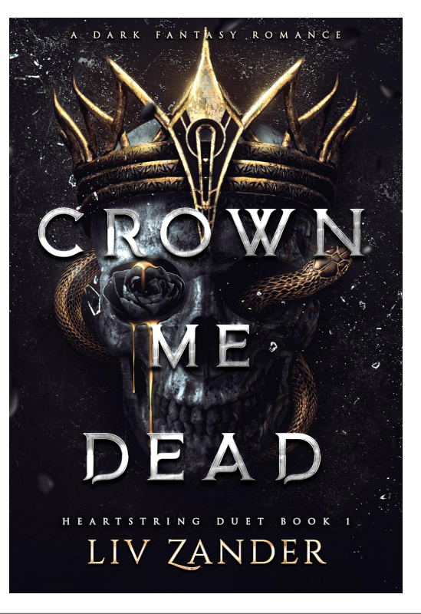

Book Review: Crown Me Dead

Title

Crown Me Dead: A Dark Fantasy Romance (Heartstring Duet Book 1)

Author

Liv Zander

Publication Details

Author: Liv Zander

Series: Heartstring Duet (Book 1)

Format: Kindle Edition

Language: English

Genre: Dark Fantasy Romance, Gothic Fiction, Fantasy Romance

Introduction

Crown Me Dead is a dark fantasy romance novel written by Liv Zander and the first book in the Heartstring Duet series. The novel combines fantasy, romance, mystery, deception, and political intrigue within a dark and dangerous world. Featuring morally grey characters, complex relationships, and emotional intensity, the story explores themes of power, sacrifice, survival, and love. The book is particularly suited for readers who enjoy dark fantasy settings and villain-centered romances.

Author Background

Liv Zander is a contemporary fantasy and dark romance author known for creating emotionally intense stories with complex characters and dark themes. Her novels often feature morally grey protagonists, high-stakes relationships, fantasy worlds, and psychological depth. She has gained popularity among readers who enjoy darker and unconventional romance stories.

Summary of the Book

The story follows a young woman whose life is transformed when her brother becomes gravely ill. Desperate to save him, she becomes entangled in a dangerous bargain that pulls her into the heart of a decaying kingdom ruled by powerful and mysterious figures.

To save her brother's life, she must navigate a world filled with secrets, deception, political manipulation, and supernatural dangers. Along the way, she encounters Kael, the feared ruler of a dying realm, and Vale, a mysterious figure whose motives remain uncertain.

As the protagonist struggles to determine whom she can trust, she discovers that appearances are often misleading. The story unfolds through betrayal, hidden agendas, dangerous attraction, and shocking revelations. What begins as a desperate attempt to save her family soon becomes a battle for survival and power in a kingdom on the brink of collapse.

Main Themes

1. Sacrifice and Survival

The novel explores how far people are willing to go to protect the ones they love, even when the cost is extremely high.

2. Power and Corruption

The story examines the influence of power and the consequences of its misuse within a decaying political system.

3. Deception and Betrayal

Secrets, lies, and manipulation play a major role throughout the narrative, creating suspense and uncertainty.

4. Love in Darkness

Unlike traditional romance novels, the relationships in Crown Me Dead develop in morally complicated circumstances, challenging conventional ideas of love and trust.

5. Identity and Choice

The characters must make difficult decisions that shape their futures and reveal who they truly are.

Main Characters

The Protagonist

A determined and courageous young woman willing to risk everything to save her brother. Her resilience and intelligence help her survive in a dangerous world.

Kael

The ruler of a decaying kingdom. Powerful, feared, and morally ambiguous, he becomes one of the central figures in the protagonist's journey.

Vale

A mysterious and calculating character whose motives remain unclear throughout much of the story. His presence adds tension and intrigue to the narrative.

Critical Reception

The novel has received strong support from readers of dark fantasy romance.

Readers praise the book's dark atmosphere and unique world-building.

Many reviewers highlight the emotional intensity and suspenseful storytelling.

The morally grey characters have been particularly popular among fantasy romance fans.

The novel maintains a high reader rating and is often recommended within the dark romance community.

Strengths of the Book

Rich and immersive fantasy world.

Strong emotional impact.

Complex and morally grey characters.

Intriguing mystery and political intrigue.

Unique blend of fantasy and dark romance.

Engaging writing style that keeps readers invested.

Weaknesses of the Book

Contains dark themes that may not be suitable for all readers.

Violence and disturbing content may be uncomfortable for some audiences.

The morally grey characters may not appeal to readers who prefer traditional heroes.

As the first book in a duet, some plotlines remain unresolved until the sequel.

Conclusion

In conclusion, Crown Me Dead is a captivating dark fantasy romance that combines mystery, deception, power struggles, and emotional depth. Liv Zander creates a fascinating world filled with danger, intrigue, and unforgettable characters. The novel stands out for its morally complex relationships and atmospheric storytelling. It is highly recommended for readers who enjoy dark fantasy, gothic romance, and character-driven stories with high emotional stakes.

References

Amazon. Crown Me Dead: A Dark Fantasy Romance (Heartstring Duet Book 1).

Liv Zander. Heartstring Duet Series.

Reader reviews and ratings from online book communities.

4);


Book Review: View from the East Wing: A Memoir

Title

View from the East Wing: A Memoir

Author

Jill Biden

Publication Details

Author: Jill Biden

Publication Date: June 2, 2026

Publisher: Gallery Books

Language: English

Pages: 288

Genre: Memoir, Biography, Politics, Social Issues

Introduction

View from the East Wing: A Memoir is a personal memoir written by Jill Biden, the former First Lady of the United States. In this book, she reflects on her experiences during her four years in the White House, sharing insights into public service, family life, education, and national challenges. The memoir offers readers a behind-the-scenes perspective on historic events while highlighting Jill Biden's dedication to her roles as a wife, mother, educator, and First Lady.

Author Background

Jill Biden is an American educator, author, and former First Lady of the United States. Before and during her time in the White House, she worked as a teacher and professor, becoming the first First Lady to maintain a full-time professional career while serving in the role. Throughout her public life, she has advocated for education, military families, cancer awareness, and women's issues. Her memoir provides a personal account of these experiences and responsibilities.

Summary of the Book

The memoir chronicles Jill Biden's journey during the presidency of her husband, Joe Biden. She describes entering the White House during a period marked by significant national challenges, including the COVID-19 pandemic and political tensions in the United States.

Throughout the book, Biden shares personal stories from her daily life in the White House, revealing both public responsibilities and private family moments. She discusses her efforts to support educational initiatives, military families, cancer research, and community programs while continuing her career as a professor.

The memoir also provides readers with an inside look at major events, official ceremonies, policy initiatives, and family experiences during the Biden administration. Through these stories, Biden reflects on leadership, service, resilience, and the importance of maintaining personal values in public life.

Main Themes

1. Public Service

The memoir emphasizes the importance of serving others and contributing to society through leadership and community engagement.

2. Education

As an educator, Jill Biden highlights the transformative power of education and her commitment to supporting students and teachers.

3. Family and Relationships

The book explores the role of family support, love, and resilience during challenging times.

4. Women's Leadership

Biden's experiences demonstrate how women can balance professional careers, family responsibilities, and public service.

5. Resilience During Crisis

The memoir reflects on navigating national crises such as the COVID-19 pandemic and political uncertainty.

Main Figures

Jill Biden

The central figure of the memoir, whose experiences and reflections shape the narrative.

Joe Biden

The President of the United States during the events described in the memoir and an important influence on the author's experiences.

The Biden Family

Family relationships and personal moments play a significant role throughout the book.

Critical Reception

The memoir has received positive attention from readers and reviewers.

Critics praise its personal and honest storytelling.

Readers appreciate the behind-the-scenes perspective on life in the White House.

The book has been recognized for its focus on education, public service, and family values.

Reviewers highlight Biden's ability to combine political history with personal reflection.

Strengths of the Book

Provides a unique insider perspective on the White House.

Personal and engaging writing style.

Insightful reflections on leadership and public service.

Strong focus on family, education, and resilience.

Accessible to both political and non-political readers.

Weaknesses of the Book

Readers seeking detailed political analysis may find it more personal than political.

Some events are presented primarily from the author's perspective.

The memoir focuses heavily on personal experiences rather than policy discussions.

Conclusion

In conclusion, View from the East Wing: A Memoir offers an intimate and inspiring account of Jill Biden's years as First Lady of the United States. Through personal stories, reflections, and behind-the-scenes experiences, she provides readers with valuable insights into leadership, family, education, and public service. The memoir is recommended for readers interested in political memoirs, biographies, women's leadership, and modern American history.

References

Amazon. View from the East Wing: A Memoir.

Gallery Books. Publication information for View from the East Wing.

Public reviews and reader discussions regarding the memoir.


5);

Book Review: මාළු යාළුවා

Title
මාළු යාළුවා

Author
Tharaka Kodithuwakku

Publication Details
- Author: Tharaka Kodithuwakku
- ASIN: B08R14DXQD
- Publication Date: December 18, 2020
- Language: English
- Format: Kindle Edition
- File Size: 1.7 MB
- Print Length: 7 Pages
- Genre: Children's Literature / Children's Nonfiction
- Accessibility Features: Screen Reader Supported, Enhanced Typesetting Enabled

Introduction
මාළු යාළුවා is a children's Kindle book written by Tharaka Kodithuwakku. Published in 2020, the book is designed for young readers and aims to provide an enjoyable reading experience through a simple and engaging presentation. With a short length and child-friendly format, the book is suitable for early readers and children who are developing an interest in reading.

Author Background
Tharaka Kodithuwakku is a Sri Lankan writer whose work contributes to children's literature. Through simple storytelling and educational themes, the author seeks to encourage reading habits among young audiences. Books such as මාළු යාළුවා help introduce children to literature in an accessible and enjoyable way.

Summary of the Book
The title මාළු යාළුවා (Fish Friend) suggests a story centered around friendship and the relationship between a child and a fish or aquatic creature. The book appears to be designed for young readers, using simple language and an easy-to-follow structure.
As a children's book, it likely aims to teach positive values such as kindness, friendship, caring for animals, and appreciating nature. The short format allows children to complete the story in a single reading session while enjoying its educational message.

Main Themes

1. Friendship
The title indicates the importance of friendship and companionship.

2. Kindness to Animals
The story may encourage children to care for animals and respect living creatures.

3. Nature and Environment
The book introduces young readers to aspects of the natural world and aquatic life.

4. Learning Through Stories
The narrative helps children develop reading skills while learning positive values.

Strengths of the Book
- Easy for young children to read.
- Short and engaging format.
- Suitable for beginner readers.
- Encourages positive values and imagination.
- Kindle accessibility features support diverse readers.

Weaknesses of the Book
- Very short length may leave readers wanting more detail.
- Limited information is available regarding the storyline.
- Older children may find the content too brief.

Book Rankings
According to Kindle Store rankings:
- #84,507 in Children's Nonfiction
- #297,710 in Children's eBooks
- #1,280,568 in Children's Books
These rankings indicate that the book belongs to the children's reading category and is available to a global audience through Amazon Kindle.

Conclusion
In conclusion, මාළු යාළුවා is a short children's Kindle book that appears to focus on friendship, k0indness, and learning through storytelling. Its simple format and accessibility features make it suitable for young readers and families looking for educational reading material. The book can serve as an enjoyable introduction to reading while promoting positive values among children.

References
Amazon Kindle Store. මාළු යාළුවා by Tharaka Kodithuwakku.
Kindle Publication Details (2020 Edition).

Rating not provided in the details shared

6);
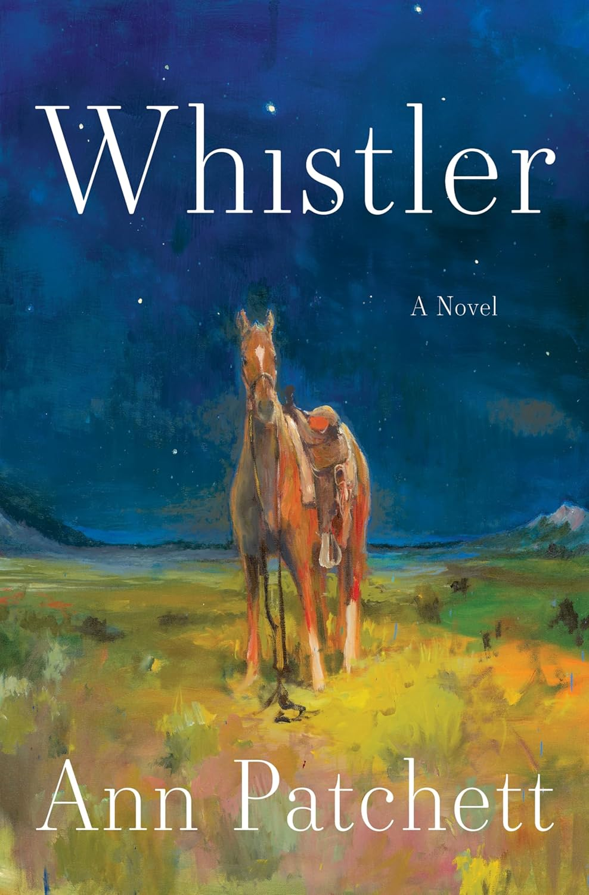

Book Review: Whistler

Title
Whistler: A Novel

Author
Ann Patchett

Publication Details
- Author: Ann Patchett
- Publication Date: June 2, 2026
- Publisher: Harper
- Language: English
- Pages: 304
- Genre: Literary Fiction, Contemporary Fiction
- Format: Hardcover

Introduction
Whistler is a literary fiction novel written by the acclaimed bestselling author Ann Patchett. The novel explores themes of memory, love, family, loss, and human connection. Through an emotional and reflective narrative, Patchett examines how brief relationships can leave lasting impressions and how past experiences continue to shape our lives. The story offers readers a thoughtful exploration of time, forgiveness, and the enduring power of love.

Author Background
Ann Patchett is an award-winning American novelist and one of the most respected contemporary literary writers. She is known for bestselling novels such as Bel Canto, The Dutch House, and Tom Lake. Her works often focus on family relationships, personal growth, and the complexities of human emotions. Patchett's writing is widely praised for its emotional depth, elegant prose, and memorable characters.

Summary of the Book
The story follows Daphne Fuller, a fifty-three-year-old woman whose life unexpectedly reconnects with her past. While visiting the Metropolitan Museum of Art with her husband, Jonathan, she notices an elderly man following them. The man turns out to be Eddie Triplett, her former stepfather.
Although Eddie was married to Daphne's mother for only a short period when Daphne was nine years old, he played an important role in her childhood. After a tragic event separated them many years ago, they lost contact and went on to live separate lives.
Their unexpected reunion brings back memories, emotions, and unanswered questions from the past. As Daphne and Eddie reconnect, they reflect on the decisions they made, the circumstances that shaped their lives, and the relationships that defined them.
The novel explores how a brief yet meaningful connection can continue to influence people across decades. Through their conversations and shared memories, Daphne and Eddie discover that some bonds can survive the passage of time.

Main Themes

1. Memory and Reflection
The novel explores how memories shape identity and influence present-day decisions.

2. Family Relationships
The story examines both traditional and non-traditional family bonds, highlighting the emotional impact of parental figures.

3. Love and Connection
Patchett emphasizes the importance of meaningful relationships and how even short-lived connections can change lives forever.

4. Loss and Impermanence
The novel reflects on the inevitability of loss and the temporary nature of life.

5. Forgiveness and Understanding
Characters learn to accept the past and find peace through understanding and reconciliation.

Main Characters

Daphne Fuller
The protagonist of the novel. Thoughtful and reflective, she is forced to confront her past after unexpectedly reuniting with her former stepfather.

Eddie Triplett
Daphne's former stepfather. Despite being part of her life for only a short period, he had a profound influence on her childhood and emotional development.

Jonathan Fuller
Daphne's supportive husband, who witnesses and supports her emotional journey throughout the novel.

Critical Reception
The novel has received significant attention as one of the most anticipated literary fiction releases of 2026.
- Selected as an Editors' Pick for Literature & Fiction.
- Praised for its emotional depth and thoughtful storytelling.
- Critics have highlighted Patchett's ability to portray complex human relationships.
- Readers appreciate the novel's exploration of memory, family, and enduring love.

Strengths of the Book
- Beautiful and elegant writing style.
- Deeply emotional and thought-provoking narrative.
- Realistic and memorable characters.
- Strong exploration of family and human relationships.
- Accessible yet profound themes.

Weaknesses of the Book
- The reflective pace may feel slow to readers who prefer action-driven stories.
- The story focuses heavily on emotions and relationships rather than dramatic plot twists.
- Some readers may find the narrative understated.

Conclusion
In conclusion, Whistler is a moving and beautifully written novel that explores memory, family, loss, and the enduring power of human connection. Ann Patchett skillfully creates a heartfelt story that reminds readers how deeply one person can influence another's life, even after years of separation. The novel is highly recommended for readers who enjoy literary fiction, character-driven stories, and emotionally rich narratives.

References
Amazon. Whistler: A Novel by Ann Patchett.
Harper Publishing. Publication information for Whistler.
Editorial reviews and reader discussions related to the novel.

⭐ Ratings
- Goodreads average rating: ⭐ 4.6 / 5
  - Around 780–840+ ratings (still increasing since it’s newly released)


7);

Book Review: Junie

Title
Junie: A Novel (GMA Book Club Pick)

Author
Erin Crosby Eckstine

Publication Details
- Author: Erin Crosby Eckstine
- Publication Date: February 3, 2026
- Format: Paperback
- Language: English
- Genre: Historical Fiction, Literary Fiction
- Recognition: GMA Book Club Pick, Editors’ Pick (Best Literature & Fiction)

Rating
- ⭐ 4.4 / 5 stars
- Based on approximately 2,438 ratings

Introduction
Junie is a historical fiction novel by Erin Crosby Eckstine and a GMA Book Club Pick. Set during the period leading up to the American Civil War, the novel follows a young enslaved girl whose life changes dramatically after a supernatural event awakens her sister’s ghost. The story blends historical reality with emotional and mystical elements, exploring themes of love, freedom, grief, and survival.

Author Background
Erin Crosby Eckstine is a contemporary author known for writing emotionally rich and historically grounded fiction. Her storytelling focuses on human resilience, family bonds, and the lived experiences of marginalized voices. Junie has brought her significant recognition due to its powerful storytelling and strong emotional impact.

Summary of the Book
The story follows Junie, a sixteen-year-old enslaved girl living on Bellereine Plantation in Alabama. She spends her days working alongside her family and serving the plantation household, while quietly grieving the loss of her older sister, Minnie.
Junie’s life takes a supernatural turn when her sister’s ghost unexpectedly returns after a desperate emotional moment. This event forces Junie to confront hidden truths about her world and the people around her.
As tensions rise with the arrival of wealthy visitors from New Orleans, Junie forms a bond with Caleb, a coachman, and begins to question her place in a world built on oppression and control. As secrets unravel, Junie must make life-changing decisions about love, freedom, and survival.

Main Themes

1. Freedom and Liberation
The novel explores the emotional and physical struggle for freedom under slavery.

2. Family and Loss
Junie’s grief over her sister’s death plays a central role in the emotional depth of the story.

3. Love and Connection
Relationships, both romantic and familial, shape Junie’s journey and decisions.

4. Supernatural Elements
The presence of a ghost adds a mystical layer to the historical setting.

5. Resistance and Survival
The story highlights courage and resistance against oppressive systems.

Critical Reception
The novel has received strong praise from readers and critics:
- Selected as a Good Morning America Book Club Pick
- Praised for emotional storytelling and character depth
- Highlighted for its poetic writing style
- Recognized for blending historical fiction with magical realism

Strengths of the Book
- Emotional and powerful storytelling
- Strong historical setting (pre-Civil War America)
- Unique mix of history and supernatural elements
- Deep character development
- Strong themes of resilience and liberation

Weaknesses of the Book
- Heavy emotional and dark themes
- Historical violence may be difficult for some readers
- Slower pacing in some sections
- Requires emotional engagement from the reader

Conclusion
In conclusion, Junie is a deeply emotional and beautifully written historical fiction novel that explores slavery, grief, love, and freedom through the eyes of a young girl. Erin Crosby Eckstine delivers a powerful narrative that combines historical reality with magical realism. The novel is highly recommended for readers who enjoy emotionally intense literary fiction with strong historical themes.

References
Amazon. Junie: A Novel by Erin Crosby Eckstine.
Good Morning America Book Club selections.
Editorial reviews and reader ratings.

8);
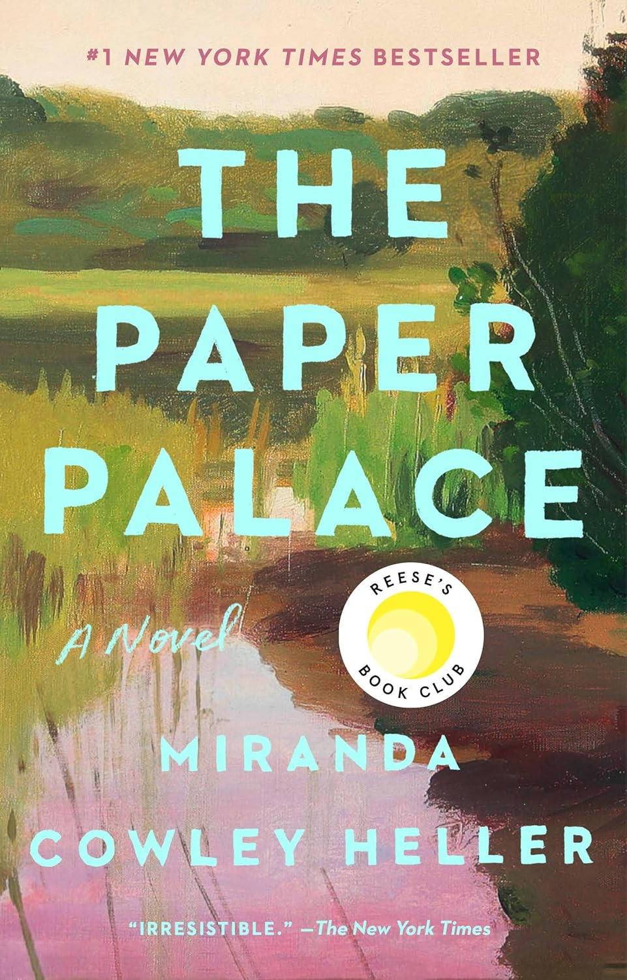

Book Review: The Paper Palace

Title
The Paper Palace (Reese’s Book Club): A Novel

Author
Miranda Cowley Heller

Publication Details
- Author: Miranda Cowley Heller
- Publication Date: April 19, 2022
- Format: Paperback
- Language: English
- Genre: Literary Fiction, Contemporary Fiction, Romance
- Recognition: Reese’s Book Club Pick, #1 New York Times Bestseller

Rating
- ⭐ 4.1 / 5 stars
- Based on approximately 93,538 ratings
- Over 2 million copies sold worldwide

Introduction
The Paper Palace is a literary fiction novel by Miranda Cowley Heller and a Reese’s Book Club Pick. The story explores love, trauma, memory, and difficult life choices through the lens of one woman’s life-changing decision. Set over the course of a single day and unfolding across decades of memories, the novel examines the complexity of relationships and the impact of past experiences on present decisions.

Author Background
Miranda Cowley Heller is an American author and former senior executive in television development. The Paper Palace is her debut novel and became an instant bestseller. Her writing is known for its emotional depth, layered storytelling, and exploration of complex human relationships, particularly within families and romantic partnerships.

Summary of the Book
The story follows Elle, a fifty-year-old woman who wakes up at her family’s summer home in Cape Cod, known as The Paper Palace. She has spent every summer of her life there, but this particular morning is different.
The night before, Elle and her childhood friend Jonas shared a secret and intimate moment, despite both being married to other people. This event forces Elle into a deep emotional conflict as she must choose between her stable life with her husband Peter and the unresolved, passionate connection she shares with Jonas.
As the story unfolds, the narrative shifts between the present day and Elle’s past, revealing childhood trauma, family secrets, and the long history between Elle and Jonas. These memories gradually explain the emotional weight behind her final decision.
The novel ultimately explores how past experiences shape identity and how love, memory, and trauma can influence life-altering choices.

Main Themes

1. Love and Desire
The novel examines the tension between emotional stability and passionate love.

2. Memory and the Past
Elle’s childhood experiences play a major role in shaping her present decisions.

3. Family and Trauma
The story explores the long-lasting effects of family secrets and personal trauma.

4. Moral Complexity
Characters are placed in morally difficult situations without clear right or wrong choices.

5. Identity and Choice
The novel focuses on how decisions define a person’s life path.

Critical Reception
The novel has received widespread attention and acclaim:
- Reese’s Book Club Pick
- #1 New York Times Bestseller
- Praised for emotional depth and storytelling complexity
- Recognized for its realistic portrayal of relationships and trauma
- Some readers find it deeply moving, while others find it emotionally heavy

Strengths of the Book
- Deep emotional storytelling
- Complex and realistic characters
- Beautiful, descriptive writing style
- Strong exploration of memory and trauma
- Engaging dual timeline structure

Weaknesses of the Book
- Emotionally heavy and intense themes
- Some readers may find the protagonist’s decisions frustrating
- Non-linear storytelling may feel complex for some readers
- Slow pacing in certain sections

Conclusion
In conclusion, The Paper Palace is a powerful and emotionally complex novel that explores love, trauma, memory, and difficult life choices. Miranda Cowley Heller delivers a deeply layered story that challenges readers to consider the impact of the past on present decisions. The book is highly recommended for readers who enjoy literary fiction, emotional narratives, and morally complex relationships.

References
Amazon. The Paper Palace by Miranda Cowley Heller.
Reese’s Book Club selections.
New York Times Bestseller listings.
Reader reviews and literary critiques.

9);


Book Review: The Most Fun We Ever Had

Title
The Most Fun We Ever Had (Reese’s Book Club Pick): A Novel

Author
Claire Lombardo

Publication Details
- Author: Claire Lombardo
- Publication Date: April 6, 2021
- Format: Paperback
- Language: English
- Genre: Literary Fiction, Family Saga
- Recognition: Reese’s Book Club Pick, New York Times Bestseller, Best Books of the Year (2019)

Rating
- ⭐ 4.1 / 5 stars
- Based on approximately 30,038 ratings

Introduction
The Most Fun We Ever Had is a family saga novel by Claire Lombardo and a Reese’s Book Club Pick. The story explores the complexities of family life, focusing on love, dysfunction, secrets, and emotional bonds between parents and their four daughters. Through humor, drama, and emotional depth, the novel portrays how family relationships evolve over time.

Author Background
Claire Lombardo is an American author known for writing emotionally rich literary fiction. Her debut novel gained critical acclaim for its detailed character development and realistic portrayal of family dynamics. Lombardo’s writing often focuses on relationships, identity, and the long-term impact of family history.

Summary of the Book
The story begins with Marilyn and David Sorenson, a couple who fall in love in the 1970s and go on to build a large family. By 2016, they have four adult daughters, each facing personal struggles and emotional challenges.
- Wendy deals with grief, alcohol, and unstable relationships.
- Violet struggles with anxiety while adjusting to life as a stay-at-home mother.
- Liza is a professor facing an unexpected pregnancy and uncertain relationship.
- Grace, the youngest, is hiding secrets that could disrupt the family balance.
The arrival of Jonah Bendt, a young man connected to the family’s past through adoption, forces the Sorensons to confront long-hidden truths. As buried secrets emerge, the family must face emotional pain, forgiveness, and the meaning of love and connection.
The novel moves between past and present, gradually revealing how choices made decades earlier continue to affect the present.

Main Themes

1. Family and Relationships
The novel deeply explores the bonds, tensions, and complexities within a large family.

2. Secrets and Consequences
Hidden truths from the past shape the present lives of the characters.

3. Identity and Personal Struggle
Each character faces internal conflict while trying to define themselves.

4. Love and Imperfection
The story shows that love within families is often messy but meaningful.

5. Time and Memory
Past decisions continue to influence present-day emotional realities.

Critical Reception
The novel has received strong literary recognition:
- Reese’s Book Club Pick
- New York Times Bestseller
- Listed among Best Books of the Year (2019)
- Praised for emotional depth and character complexity
- Recognized for realistic family storytelling

Strengths of the Book
- Rich and detailed character development
- Realistic portrayal of family dynamics
- Emotional and layered storytelling
- Multiple perspectives add depth
- Strong literary writing style

Weaknesses of the Book
- Lengthy and slow-paced at times
- Large cast of characters can feel overwhelming
- Emotionally heavy themes throughout
- Requires patience for detailed storytelling

Conclusion
In conclusion, The Most Fun We Ever Had is a powerful family saga that explores love, secrets, and emotional complexity across generations. Claire Lombardo delivers a deeply human story that highlights both the beauty and difficulty of family life. The novel is highly recommended for readers who enjoy literary fiction, multi-generational stories, and emotionally rich narratives.

References
Amazon. The Most Fun We Ever Had by Claire Lombardo.
Reese’s Book Club selections.
New York Times Bestseller listings.
Reader reviews and literary critiques.

10);
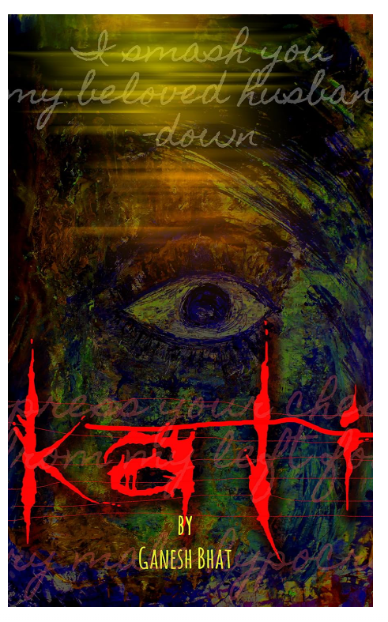

Book Review: Kali

Title
Kali (Kindle Edition): A Novel

Author
Ganesh Bhat

Publication Details
- Author: Ganesh Bhat
- Publication Date: July 21, 2015
- Format: Kindle Edition
- Language: English
- Genre: Psychological Fiction, Crime Thriller, Dark Fiction
- Reading Age: 15–18 years
- Length: 192 pages
- Kindle File Size: 1.7 MB
- Best Sellers Rank (Amazon Kindle Store):
  - Psychological Fiction
  - Police Procedurals
  - Crime-related fiction categories

Rating
- ⭐ Not officially rated on a single universal scale (varies by reader platforms)
- Generally considered a dark psychological thriller with mixed-to-positive reader interest due to its intense themes

Introduction
Kali by Ganesh Bhat is a dark psychological crime thriller that explores the disturbing underbelly of modern society. The novel combines crime investigation with mythological symbolism, particularly referencing the goddess Kali as a representation of destruction, anger, and transformation.
The story is not just a simple police procedural; it dives deeply into themes of violence, corruption, and moral decay within society. Through intense imagery and symbolic storytelling, the novel attempts to portray how evil and justice often coexist in a blurred moral world.

Author Background
Ganesh Bhat is an Indian author known for writing crime and psychological fiction. His works often include dark themes, social commentary, and symbolic storytelling.
In Kali, Bhat uses a blend of mythology and modern crime narrative to create a disturbing yet thought-provoking reading experience. His writing style is heavy on symbolism and psychological tension rather than traditional linear storytelling.

Summary of the Book
The story follows Mitra, a police superintendent who begins investigating a series of disturbing crimes spreading across cities. At the same time, he is emotionally disturbed by the disappearance of his wife and mysterious messages that seem connected to a hidden underground organization.
As Mitra investigates deeper, he discovers a violent network operating with extreme brutality and ideological motivations. The crimes are not random—they appear ritualistic and symbolic, connected to a larger philosophy of chaos and revolution.
The novel introduces horrifying imagery such as mutilated bodies and symbolic representations of violence, which are linked to the concept of Kali, the goddess often associated with destruction and rebirth.
As the investigation continues, Mitra struggles to separate reality from symbolism, truth from manipulation, and justice from revenge.

Main Themes

1. Crime and Corruption
The novel highlights the spread of organized crime and moral decay in urban society.

2. Psychological Breakdown
Mitra’s emotional and mental state deteriorates as he faces disturbing truths.

3. Violence and Brutality
Graphic depictions of violence emphasize the extreme darkness of human behavior.

4. Mythological Symbolism
The goddess Kali is used as a symbol of destruction, rage, and transformation.

5. Justice vs Revenge
The novel questions whether justice is truly separate from revenge and chaos.

6. Revolution and Extremism
The underground organization represents ideological extremism disguised as social change.

Main Characters

Mitra
- Police Superintendent
- Central investigator of the crimes
- Emotionally affected by his wife’s disappearance
- Struggles with truth, reality, and psychological pressure

The Underground Organization
- Secret violent network operating across cities
- Engaged in brutal and symbolic crimes
- Represents chaos, ideology, and social rebellion

Symbolism in the Novel
- Kali (Goddess): Represents destruction, fear, transformation, and rebirth
- Human Body Imagery: Reflects moral decay and brutality in society
- Ritual-like Crimes: Symbolize ideological extremism and chaos
- Dark Night / Violence Motifs: Represent confusion and loss of moral direction

Critical Reception
- Not widely mainstream reviewed but noted in niche psychological thriller readership
- Appreciated for:
  - Dark and intense atmosphere
  - Mythological integration
  - Psychological depth
- Criticized for:
  - Extremely graphic and disturbing imagery
  - Complex symbolism that may be difficult to interpret
  - Heavy, dark tone throughout

Strengths of the Book
- Unique combination of mythology and crime thriller
- Strong psychological depth
- Dark and atmospheric storytelling
- Symbolic and thought-provoking narrative
- Engaging mystery structure

Weaknesses of the Book
- Graphic violence may be uncomfortable for readers
- Complex symbolism can be confusing
- Heavy tone with little emotional relief
- Not suitable for light readers

Conclusion
Kali by Ganesh Bhat is a dark psychological thriller that explores crime, violence, and mythological symbolism in a deeply disturbing yet intellectually engaging way. The novel challenges readers with its intense imagery and moral ambiguity, making it more suitable for mature readers who appreciate dark fiction and symbolic storytelling.

References
- Amazon Kindle Store product listing: Kali by Ganesh Bhat
- Reader descriptions and book summaries
- Genre classification (Psychological Fiction / Crime Thriller)
- Literary interpretation of mythological symbolism

